CLERK OF SUPERIOR COURT

FINANCIAL POLICIES AND PROCEDURES

**STATE OF NORTH CAROLINA**

**ADMINISTRATIVE OFFICE OF THE COURTS**

**Copyright ©2002, North Carolina Administrative Office of the Courts**

# NOVEMBER 15, 2002

**TABLE OF CONTENTS**

**INTRODU****CTION**CHAPTER DATE 11/15/02 **1.1**

#### The Administrative Office of the Courts 1.1

##### The CSC Financial Policies and Procedures Manual 1.1

##### Forms 1.2

References 1.2

Revisions 1.2

**INTERNAL CONTROL**CHAPTER DATE 12/31/01 **2.1**

#### System of Authorizations and Approvals 2.1

Segregation of Duties 2.2

Internal Reliability 2.2

Physical Control over Assets and Records 2.2

##### CSC Internal Control Exception Form (AOC-FP-0200) 2.3

**SECURITY** **2.4**

#### Security Profiles in FMS and MFCR 2.4

#### Reviewing Security Passkeys 2.5

##### Security in other Computer Systems 2.8

##### Security and Segregation of Duties 2.9

### Security File Approval for

### Automated Systems Form (AOC-A-151) 2.11

**JURY, WITNESS AND INTERPRETER**CHAPTER DATE 11/15/02 **10.1**

JURY 10.1

#### Jury Fees 10.1

#### Defining Service 10.2

#### Payment of Jury Fees 10.2

##### Jury Expenses 10.3

##### Mileage 10.3

Lodging and Meals 10.4

##### Payment of Jury Expenses 10.4

##### **\*JURY, WITNESS AND INTERPRETER CONTINUED\***

##### Auditing Jury 10.5

Reimbursement of Jury Fees and Expenses 10.5

WITNESS 10.6

#### Witness Fees 10.6

### Payment of Witness Fees 10.6

##### Witness Expenses 10.7

### Payment of Witness Expenses 10.8

##### Auditing Witness 10.9

Reimbursement of Witness Fees and Expenses 10.9

Defendant is Ordered to Pay 10.10

EXPERT WITNESS FEES AND EXPENSES 10.11

### Disbursed by the AOC 10.11

#### Disbursed by the CSC 10.12

##### Requesting Reimbursement 10.13

##### Auditing Expert Witness Fees and Expenses 10.14

Defendant is Ordered to Pay 10.15

INTERPRETER FEES 10.16

#### Disbursed by the AOC 10.16

#### Disbursed by the CSC 10.16

#### Requesting Reimbursement 10.18

##### Auditing Interpreter Fees and Expenses 10.19

Defendant is Ordered to Pay 10.19

THE AOC REIMBURSEMENT CHECK 10.20

#### Receipting the AOC Reimbursement Check 10.21

**PARTIAL PAYMENTS CHAPTER IN PROCESS 18**

**APPENDIX**

Statutory References (<http://www.ncleg.net>) A

October 2, 1996 Memo regarding

Juror’s days served DATED 10/02/96 F

**FORMS**

**CHAPTER TWO:**

AOC-FP-0200 CSC INTERNAL CONTROL

EXCEPTION FORM (http://www.nccourts.org/Forms/Documents/…)

AOC-A-151 SECURITY APPROVAL (http://www.nccourts.org/Forms/Documents/619.pdf)

**CHAPTER TEN:**

AOC-FP-1000 CSC WAIVER OF JUROR FEES

(http://www.nccourts.org/Forms/Documents/…)

#### AOC-CR-235 WITNESS ATTENDANCE CERTIFICATE FORM

(http://www.nccourts.org/Forms/Documents/76.pdf)

AOC-CR-231 ORDER FOR EXPERT WITNESS FEE DATED 6/82 F10.1

#### AOC-G-107 MOTION, APPOINTMENT AND ORDER AUTHORIZING

#### PAYMENT OF INTERPRETER (http://www.nccourts.org/Forms/Documents/833.pdf)

INTRODUCTION

(G.S. 7A-108, 7A-343)

THE ADMINISTRATIVE OFFICE OF THE COURTS

North Carolina General Statute 7A-108 (http://www.ncleg.net/Enacted Legislation/Statutes/HTML/BySection/Chapter_7A/GS_7A-108.html) states:

“The Administrative Office of the Courts, subject to the approval of the State Auditor, shall establish procedures for the receipt, deposit, protection, investment, and disbursement of all funds coming into the hands of the Clerk of Superior Court.”

In addition, North Carolina General Statute 7A-343 (http://www.ncleg.net/Enacted Legislation/Statutes/HTML/BySection/Chapter_7A/GS_7A-343.html) charges the Director of the Administrative Office of the Courts (AOC) with several duties. The third duty listed is:

“Prescribe uniform administrative and business methods, systems, forms and records to be used in the offices of the Clerks of Superior Court”

THE CSC FINANCIAL POLICIES AND PROCEDURES MANUAL

This manual is written to prescribe uniform business methods for the financial areas of the offices of the Clerks of Superior Court. The policies and procedures herein are based on sound accounting principles and business practices.

The usage of words such as ‘must’, ‘should’ and ‘could’ is intentional. They are defined as follows:

Must: = North Carolina General Statute deem this an obligation or necessity

Should: = AOC highly recommends this policy or procedure

Could: = AOC recommends this policy or procedure

The AOC understands and recognizes that in some offices it may not be possible to follow all the prescribed methods. For those offices the CSC Internal Control Exception Form (AOC-FP-0200) (http://www.nccourts.org/Forms/Documents…) should be completed. (See Chapter 2, INTERNAL CONTROL.)FORMS

The forms referred to in this manual are linked to the appropriate website to give you the most current version of the form. The AOC forms (which includes the ‘FP’ forms) can also be found at the following website:

<http://www.nccourts.org/Forms/FormSearch.asp>

If a form is not available online, there will be a copy of it in this online manual.

**NOTE:** The ‘FP’ forms (Financial Policies) in this manual are **not** stocked forms. You cannot order them. When you need to use a ‘FP’ form, do a print screen of the form.

The State Treasurer escheat forms can also be found at the following website:

<http://www.treasurer.state.nc.us>

REFERENCES

To assist the user in finding information faster you will find the following:

1. References to another chapter in the manual will appear as:  
   (See Chapter…)  
   References to another section in the same chapter will appear as:  
   (See the Section…)

These references will be linked directly to the application Chapter or Section.

1. The ‘FP’ forms have a four-digit number, with the first two digits referring to the chapter in which they are discussed.  
   (Example: Form AOC-FP-0305 is discussed in Chapter 3.)
2. The ability to search for key words. *(How does this work?)*

REVISIONS

Each page of the Financial Policies and Procedures Manual has a chapter date at the bottom of the page. This chapter date is listed after each chapter heading in the Table of Contents.

INTERNAL CONTROL

Internal controls comprise the methods and procedures directly associated with the safeguarding of assets and the reliability of accounting data. These controls include:

1. The systems of authorizations and approvals
2. Segregation of duties
3. Internal reliability
4. Physical control over assets and records

Internal administrative controls comprise the methods and procedures that are concerned mainly with operational efficiency and adherence to managerial policies.

Internal accounting control objectives specify what must be accomplished to fulfill the function of providing reasonable assurance that government assets are sufficiently protected and financial reports are accurate and reliable. The following are four objectives of internal accounting control systems:

1. To provide reasonable assurance that transactions are executed according to management’s general and specific authorizations.
2. To provide reasonable assurance that transactions are recorded in appropriate detail to:
3. Permit preparation of financial statements in conformity with generally accepted accounting principles or any other criteria applicable to such statements
4. Maintain accountability for assets
5. To provide reasonable assurance that access to assets is limited to those individuals who have specific authorization from management.
6. To provide reasonable assurance that accountability for assets is compared with existing assets at reasonable intervals and appropriate action is taken concerning any differences.

# SYSTEM OF AUTHORIZATIONS AND APPROVALS

For good internal control every financial transaction has to go through certain steps: authorized, initiated, executed and recorded. For purposes of internal accounting control each CSC should have a system that makes reasonably sure that:

1. Only legitimate and appropriate transactions are authorized
2. Only authorized transactions are initiated, executed and recorded
3. Any errors in execution or recording are detected as soon as possible

# SEGREGATION OF DUTIES

Specific responsibility for the performance of duties must be assigned to specific individuals if the system is to operate effectively and work is to be performed properly.

The control features of segregation of duties are important enough to be adopted whether efficiency or inefficiency is the consequence. If different people handle two parts of a transaction, each serves as a check on the other, providing some assurance that each operation was accurately performed.

In order to achieve good internal control in the financial area of your office, one person should not be able to perform more than one of the following tasks:

1. Receipt money
2. Make the final count and deposit of money
3. Enter Payment Authorizations Forms (which generate checks)
4. Reconcile the bank statement(s)

Good internal control does not prevent every possible problem, but it makes the misuse of funds more difficult. Internal control provides protection for the CSC and their employees. (See the Section SECURITY AND SEGREGATION OF DUTIES.)

# INTERNAL RELIABILITY

An employee could manipulate account balances so that errors or irregularities may be difficult to detect. If another person occasionally performs these duties a manipulation could become apparent. The rotation of duties is an important part of good internal control. There should be both a primary and a back up individual assigned to each area of responsibility. Back up individuals should fill in on a regular basis to ensure that they remain familiar with the duties and are able to perform the operations.

# PHYSICAL CONTROL OVER ASSETS AND RECORDS

If unauthorized transactions are to be prevented, whether they constitute theft or simply well intentioned activity not consistent with policy, the restriction of access to all items that could be used to initiate or process a transaction is necessary. Restricted access is most commonly thought of in connection with negotiable assets: cash, securities, inventory and other items that are easily convertible to

Restricted access is evidenced by physical security: a safe, a vault, a locked cash drawer or a locked door. Cash should be kept in a safe and the safe should be locked when unattended. Physical safeguards are useless, however, without controls that prevent unauthorized individuals from entering.

Physical security measures should also protect assets and records from physical threat such as accidental destruction, deterioration or loss. Items, which cannot be reconstructed, should be kept overnight in a locked fireproof safe or vault.

CSC INTERNAL CONTROL EXCEPTION FORM (AOC-FP-0200)

Some offices may not be able to follow all the prescribed methods. For such offices, the CSC Internal Control Exception Form (AOC-FP-0200) (http://www.nccourts.org/Forms/Documents…) should be completed and filed with the AOC. Your Financial Management Analyst (FMA) can assist you in completing the form.

In addition, an alternative procedure may be adopted. If you are submitting an alternative procedure include a detailed description of the proposed procedure with the CSC Internal Control Exception Form. If the alternative procedure is approved by the AOC, your FMA will give you a written approval. The written approval should be attached to your copy of the form. If it is not approved, your FMA will contact you personally and review the procedure. The approved alternative procedures are part of the basis for the AOC audit.

The original CSC Internal Control Exception Form should be retained in the CSC office. A copy should be forwarded to:

###### AOC FMA Division

###### PO Box 456

Jamestown, NC 27282

#### **SECURITY**

There are numerous computer systems that your office utilizes and currently most of them have separate security capabilities. The Financial Management System (FMS) allows you to view it’s security profiles in four applications:

1. Mainframe Cash Receipting
2. General Ledger
3. Partial Pay
4. Jury Payment

# SECURITY PROFILES IN FMS AND MFCR

Security in FMS and MFCR (Mainframe Cash Receipting) is maintained through the use of passkeys. A specific user is assigned a passkey that determines the access they have to display and/or update screens. Access can be limited screen-by-screen, thereby allowing the AOC Security Administrator to customize a passkey to the needs of the users.

CSC’s should review employees’ security passkeys on a quarterly basis to determine if changes are needed. When determining if a change is needed keep in mind the guidelines for segregation of duties. (See the Section SECURITY AND SEGREGATION OF DUTIES.)

# REVIEWING SECURITY PASSKEYS

To access the security passkeys, type the following command line in FMS:

>GD 999 (where ‘999’ is the county number) on CTSUL

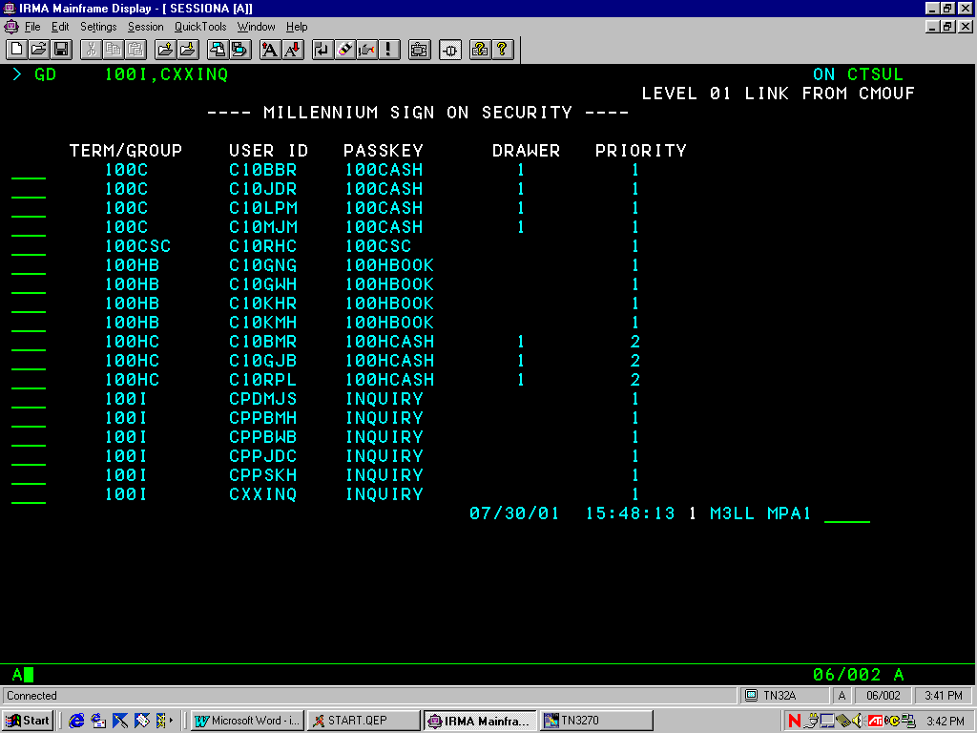This screen will display all users in the requested county and will show the passkey assigned to each user. An example of what the screen will look like is shown below:

To access the security passkeys with the list of user names, type the following command line in FMS:

>GD 999 (where ‘999’ is the county number) on CTSLS

This screen will display all users in the requested county and will show the passkey assigned to each user. An example of what the screen will look like is shown below:

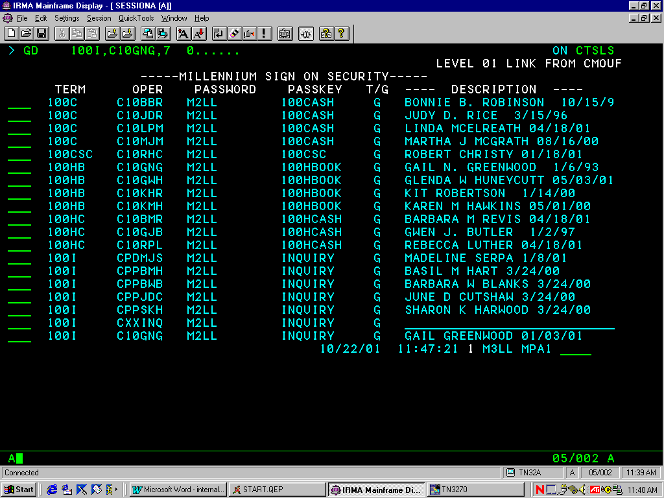

The follow page explains each passkey and the functions that are assigned to it:

PASSKEY TITLE and functions

### CASH CASHIER

1. Enters Receipts

### CSC CLERK OF COURT

1. Accesses All Inquiry Functions

### DOCI DEPT. OF CORRECTIONS UPDATE TO OFFICER CODE

1. Accesses All Inquiry Functions
2. Updates Access to Probation Officer Code on Bill of Cost in the FMS Partial Pay application

### HBOOK HEAD BOOKKEEPER

1. Performs Distributions of Funds
2. Enters Payment Authorizations Forms
3. Enters Journal Entries
4. Enters Bills of Costs
5. Enters Jurors for Payment
6. Performs Supervisor Functions in the FMS Accounts Payable application
7. Accesses all Inquiry Functions

HCASH HEAD CASHIER

1. Voids Receipts
2. Closes out Cashiers
3. Reopens Batches
4. Prints Total Closed Batches

### INQUIRY INQUIRY

1. Accesses All Inquiry Functions

### JCLERK JURY CLERK

1. Enters Jurors for Payment

### PPAY PARTIAL PAY CLERK

1. Enters Bills of Costs

### SCASH***[1]*** SPECIAL CASHIER

1. Enters Receipts
2. Voids Receipts
3. Closes out Cashiers
4. Reopens Batches
5. Prints Total Closed Batches

SECURITY IN OTHER COMPUTER SYSTEMS

In order to review security in the Support Enforcement System (SES) and the Automated Criminal/Infraction System (ACIS), the CSC should contact the AOC Security Administrator at (919) 755-5360. They will be able to give you the security information regarding those systems.

# Support Enforcement System (SES)

SES maintains security through the use of passwords and an access level. The levels of security are Supervisor, Bookkeeper and Inquiry. The following explains each access level and the functions assigned to it:

### SES SUPERVISOR

1. Performs County Maintenance
2. Changes Case Numbers
3. Marks Cases for Deletion
4. Reactivates Cases
5. Enters Credit Adjustments
6. Performs All other functions

###### SES BOOKKEEPER

1. Performs All other functions

###### SES INQUIRY

1. Accesses Inquiry functions

SES PRINT

1. Displays reports
2. Prints reports
3. Reroutes reports to another printer
4. Deletes reports

SES PRINT (INQUIRY)

1. Displays reports

SECURITY AND SEGREGATION OF DUTIES

To accomplish good segregation of duties follow these guidelines for security profiles:

Key: ACIS = Automated Criminal/Infraction System  
 FMS = Financial Management System

FMS PRINT = Print facility for FMS  
 MFCR = Mainframe Cash Receipting

1. Head Bookkeeper in FMS can be

Supervisor or lower in SES or SES PRINT

Should not be:

Head Cashier, Cashier or Special Cashier in MFCR

Update status in ACIS

1. Head Cashier in MFCR can be

Supervisor or lower in SES

Supervisor or lower in SES PRINT

Partial Pay Clerk in FMS

Jury Clerk in FMS

Should not be:

Cashier or Special Cashier in MFCR

Head Bookkeeper in FMS

Update status in ACIS

1. Cashier in MFCR can be:

Partial Pay Clerk or Jury Clerk in FMS

Should not be:

Head Cashier or Special Cashier in MFCR

Head Bookkeeper in FMS

Update status in ACIS

1. Special Cashier in MFCR can be:

Partial Pay Clerk or Jury Clerk in FMS

Should not be:

Head Cashier or Cashier in MFCR

Head Bookkeeper in FMS

Update status in ACIS

1. Supervisor in SES can be:

Head Bookkeeper or lower in FMS

Bookkeeper or lower in SES PRINT

Should not be:

Head Cashier or Cashier in MFCR

1. Bookkeeper in SES can be:

Head Bookkeeper or lower in FMS

Bookkeeper or lower in SES PRINT

Head Cashier or Cashier in MFCR

Should not be:

1. Update status in ACIS can be:

Bookkeeper or lower in SES PRINT

Should not be:  
Head Bookkeeper in FMS  
Head Cashier, Cashier or Special Cashier in MFCR

SECURITY APPROVAL FORM (AOC-A-151)

The Security Approval Form (AOC-A-151) (http:www.nccourts.org/Forms/Documents/619.pdf) is used for all additions, updates and deletions to the security in all the AOC computer systems***.[2]***

Instructions are written near the top of the form. Fill in the form completely. The middle initial of the person requesting access is required. The signature of either the CSC or a designee of the CSC is required as the “Hiring Authority”.

The form may be mailed or faxed. If you mail the form a copy should be retained in the CSC office. The original should be forwarded to:

AOC - Trial Court Services

###### Security Administrator

P.O. Box 2448

Raleigh, NC 27602

Courier 56-10-50

If you fax the form send it to AOC – Trial Court Services, fax number 919-715-4527. The original should be retained in the CSC office.

After the access has been added, updated or deleted, a member of the AOC Security Team will either send a fax, make a phone call or send an email to confirm that the request was granted.

# JURY, WITNESS AND INTERPRETER

# JURY (G.S. 7A-312) (<http://www.ncleg.net/EnactedLegislation/Statutes/HTML/BySection/Chapter_7A/GS_7A-312.html>)

The jury clerk must certify the jurors before a jury payment can be processed. Certification can be in the form of a list or a set of cards. The certification should include the following information.***[3]***

1. Juror Name
2. Juror Address
3. Juror Social Security Number***[4]***
4. Type of Court
5. Type of Jury
6. Number of Days Served

JURY FEES

Each Juror (Petit, Coroner’s, District or Superior Court, or Pool) must be paid $12.00 per day for each day served up to 5 days.

If any person serves as a juror for more than 5 days in a 24-month period they must be paid $30.00 per day for each day served in excess of the 5 days.

If a juror elects to waive the service fee, they should complete the CSC Waiver of Juror Fees Form (AOC-FP-1000). (http://www.nccourts.org/Forms/Documents…)

Grand Jurors must be paid $12.00 per day for their service regardless of the number of days served.

* DEFINING SERVICE

Service can be defined as taking the preliminary or initial oath. This includes being entered into a jury pool (whether ever selected to enter a courtroom to be questioned as a prospective juror or not).

“Days served” does not include the following:

* Days when the juror only calls in for instructions ***[5]***
* Days when the juror arrives on the date of service seeking to be excused and is excused (this juror never enters the jury pool)
* Days when the juror arrives on the date of service and is deferred to a later date

## PAYMENT OF JURY FEES

There are two ways of processing jury fees:

1. A Payment Authorization Form may be completed for each batch/payment.
2. The jury list/cards may be used as authorization to pay.

Use the FMS Jury Payment System to pay jurors.***[6]*** A payment number needs to be assigned. The type of payment number used will vary from county to county. The following are some common examples:

* A Payment Authorization Form is attached to a jury list and the payment number used is the one that is pre-printed on the form.
* A payment number of JPMMDDYY is used where ‘JP’ refers to Jury Payment and ‘MMDDYY’ is the date of the jury list. The payment number should be written on the list in the bottom right corner and along the upper right side so that when the list is filed the number is legible. See the example on the next page:
* Each juror is assigned a number on a card. The payment number is MMDDYY9999 where ‘MMDDYY’ is the date on the card and ‘9999’ is the juror number (this method works particularly well if the cards are stored in batches by date and are sorted in order by the juror number). If the juror number assigned to the card is 6 digits, drop the year portion of the date as follows: MMDD999999.



### JURY EXPENSES

There are two types of jury expenses:

1. Mileage
2. Lodging and meals

* MILEAGE

If any person living outside the county serves as a juror they must receive mileage reimbursement at the same rate as State employees.***[7]***

Jurors from out of the county summoned to sit on a special venire shall receive mileage at the same rate as State employees. ***5***

* LODGING AND MEALS

A court order is required for payment of lodging and meal(s) expenses for jurors.***[8]*** The applicable receipts should be attached when requesting payment for lodging and/or meals.

* A juror required to remain overnight at the site of the trial shall be reimbursed for both lodging and meals.
* A jury, if required by the presiding judge to remain in a body during the trial of a case, shall be furnished meals during the period of sequestration. (If applicable, the meals can be reimbursed.)

## PAYMENT OF JURY EXPENSES

Either complete a Payment Authorization Form or use a copy of the court order to process the payment for lodging and/or meals. If the latter is used the payment number should be COMMDDYY where ‘CO’ refers to court order and ‘MMDDYY’ is the date the judge signed the order. The payment number should be written on the copy of the court order at the bottom right corner and along the upper right side so that when it is filed the number is legible. For example:



## AUDITING JURY

Records should be maintained in order to provide an audit trail for jury fees and expenses.

For record keeping of jury fees paid, retain one of the following (based on your method of payment) in the CSC’s office:

1. The white copy of the Payment Authorization Form in date processed order, with the jury lists attached.
2. Jury list filed by date.
3. Jury cards filed by date.

For record keeping of jury expenses paid, retain one of the following (based on your method of payment) in the CSC’s office:

1. The white copy of the Payment Authorization Form in date processed order, with the copy of the court order and associated bills attached.
2. The copy of the court order in date order, with the associated bills attached.

Each month the Bookkeeper should compare the jury fees and expenses that were paid to the appropriate General Ledger accounts (17001, 17111 and 17211). The total debits for the General Ledger accounts should equal the total of the paid jury items.***[9]*** Correct any errors found. Consult your Financial Management Analyst (FMA) if you need assistance.

## REIMBURSEMENT OF JURY FEES AND EXPENSES

Jury fees and expenses are automatically repaid by the AOC based upon month-end balances. See the Section THE AOC REIMBURSEMENT CHECK for detailed instructions.

**WITNESS (G.S. 7A-314, 7A-315)** (<http://www.ncleg.net/EnactedLegislation/Statutes/HTML/BySection/Chapter_7A/GS_7A-314.html> and (<http://www.ncleg.net/EnactedLegislation/Statutes/HTML/BySection/Chapter_7A/GS_7A-315.html>)

The presiding judicial official (court or CSC) must certify each witness in a criminal case before the witness payment can be processed. To certify a witness, complete the Witness Attendance Certificate Form (AOC-CR-235). (http://www.nccourts.org/Forms/Documents/76.pdf) If the witness resides in a state other than North Carolina, Side Two (of the form) needs to be signed by the Judge.

## WITNESS FEES

Each certified witness (other than a salaried state, county or municipal law-enforcement officer or an out-of-state witness in a criminal case) must be paid $5.00 per day or fraction thereof.

Out-of-state witnesses in criminal cases are entitled to $5.00 for each day that they are required to travel. (See the Section WITNESS EXPENSES.)

This holds true even if the case was dismissed or if the defense issued the subpoena. However, if more than two witnesses are subpoenaed to prove a single material fact, the expense of the additional witnesses shall be borne by the issuing party. (General Statute 7A-316)

(http://www.ncleg.net/EnactedLegislation/Statutes/HTML/BySection/Chapter_7A/GS_7A-316.html)

## PAYMENT OF WITNESS FEES *[10]*

Once the Bookkeeper receives a completed Witness Attendance Certificate Form (AOC-CR-235) (<http://www.nccourts.org/Forms/Documents/76.pdf>) they use the FMS Accounts Payable System to pay the witness.***[11]*** Either complete a Payment Authorization Form or use a copy of the court order to pay the witness. If you choose the latter, assign the payment number as WMMDDYY999 where ‘W’ refers to witness and ‘MMDDYY’ is the date the order was signed and ‘999’ is a sequence number beginning with the number 001 for the first order with that date. The payment number should be written on the copy of the court order at the bottom right corner and along the upper right side so that when it is filed the number is legible. For example:



WITNESS EXPENSES

A witness entitled to the fees mentioned on the previous page is also entitled to receive reimbursement for travel expenses as follows:

1. If they live outside the county, but within 75 miles, reimburse mileage at the same rate as State employees.***[12]***
2. If they live outside the county and more than 75 miles from the place of appearance, reimburse mileage at the same rate as State employees***12*** for one round-trip. If they are required to appear more than one day then you must also reimburse actual expenses incurred for lodging and meals, not to exceed the maximum currently authorized for State employees.***[13]*** (If lodging and meals are claimed the substantiating receipts need to be attached to the Witness Attendance Certificate Form.)
3. If they do not live in North Carolina and testify for a criminal case, reimburse mileage at the same rate as State employees***12*** for one round-trip from their home to the place of appearance and $5.00 for each day that they are required to travel. If they are required to appear more than one day, reimburse for actual expenses incurred for lodging and meals not to exceed the maximum currently authorized for State employees.***11***  (If lodging and meals are claimed the substantiating receipts need to be attached to the Witness Attendance Certificate Form.)

## PAYMENT OF WITNESS EXPENSES

Once the Bookkeeper receives a completed Witness Attendance Certificate Form,***[14]*** (AOC-CR-235) (<http://www.nccourts.org/Forms/Documents/76.pdf>) they use the FMS Accounts Payable System to pay the witness.***[15]*** Either complete a Payment Authorization Form or use a copy of the Witness Attendance Certificate Form to pay the witness. If you choose the latter, assign the payment number as WMMDDYY999 where ‘W’ refers to witness and ‘MMDDYY’ is the date the order was signed and ‘999’ is a sequence number beginning with the number 001 for the first order with that date. The payment number should be written on the copy of the Witness Attendance Certificate Form at the bottom right corner and along the upper right side so that when it is filed the number is legible. For example:



## AUDITING WITNESS

Records should be maintained in order to provide an audit trail for witness fees and expenses.

For record keeping of witness fees paid, retain one of the following (based on your method of payment) in the CSC’s office:

1. The white copy of the Payment Authorization Form in date processed order, with the Witness Attendance Certificate Form and associated expense receipts attached.
2. The Witness Attendance Certificate Form filed by the assigned payment number.

For record keeping of witness expenses paid, retain one of the following (based on your method of payment) in the CSC’s office:

1. The white copy of the Payment Authorization Form in date processed order, with the Witness Attendance Certificate Form and associated expense receipts attached.
2. The Witness Attendance Certificate Form in payment number order, with the expense receipts attached.

Each month the Bookkeeper should compare the witness fees and expenses that were paid to the appropriate General Ledger accounts (17112, 17115, 17212 and 17215). The total debits for the General Ledger accounts should equal the total of the paid witness items. Correct any errors found. Consult your Financial Management Analyst (FMA) if you need assistance.

## REIMBURSEMENT OF WITNESS FEES AND EXPENSES

Witness fees***[16]***and expenses are automatically repaid by the AOC based upon month-end balances. See the Section THE AOC REIMBURSEMENT CHECK for detailed instructions.

### DEFENDANT IS ORDERED TO PAY

A judge may include the state witness fees and/or expenses as part of the Bill of Cost for a defendant. You still need to have a completed Witness Attendance Certificate Form (AOC-CR-235).***[17]*** (http://www.nccourts.org/Forms/Documents/76.pdf) See the Section PAYMENT OF WITNESS FEES or PAYMENT OF WITNESS EXPENSES for instructions on how to get a check to the witness.

Include the cost ordered on the defendant’s Bill of Cost in the Partial Pay application using the appropriate General Ledger account (or have the Cashier receipt it to):

24671 Recovery of Superior Court Criminal Witness Fees and Expenses

24672 Recovery of District Court Criminal Witness Fees and Expenses

The Partial Pay application (or Mainframe Cash Receipting) will distribute funds to these accounts. ***[18]*** These accounts are roll-ups and will automatically disburse the funds to the AOC.

**EXPERT WITNESS FEES AND EXPENSES (G.S. 7A-314, 7A-454)** (<http://www.ncleg.net/EnactedLegislation/Statutes/HTML/BySection/Chapter_7A/GS_7A-314.html> (<http://www.ncleg.net/EnactedLegislation/Statutes/HTML/BySection/Chapter_7A/GS_7A-454.html>)

The presiding judicial official (court or CSC) must certify each expert witness in a criminal case before the expert witness payment can be processed. To certify an expert witness, complete the [Order for Expert Witness Fee (AOC-CR-231,  
page F10.1](#aoccr231)).***[19]*** If expenses are claimed the substantiating receipts need to be attached.

An expert witness, (other than a salaried state, county or municipal law-enforcement officer) must receive such compensation and allowances as the court, in its discretion, may authorize.

If the expert witness is a law-enforcement officer they only receive reimbursement for travel expenses.

## DISBURSED BY THE AOC

Expert witnesses should be paid by the AOC.

Simply mail a copy of the Order for [Expert Witness Fee Form (AOC-CR-231,  
page F10.1](#aoccr231)) with the appropriate receipts attached to:

AOC Financial Services

P.O. Box 2448

Raleigh, NC 27602

Courier # 56-10-50

AOC Financial Services will generate a check to pay the expert witness. AOC also issues a 1099Misc if the expert witness received $600 or more from the AOC within a calendar year.

(If it is determined that the CSC needs to issue the check to the expert witness, see the Section DISBURSED BY THE CSC on the next page.)

## DISBURSED BY THE CSC

On rare occasions a judge may order the CSC to issue the check to the expert witness. **Please note that if the CSC pays the expert witness they will have to issue a 1099Misc (at the end of the calendar year), if applicable.*[20]***

**NOTE:** It is best if the AOC pays the expert witness as they can then issue the 1099M, if applicable.***[21]***

The Order for Expert Witness Fee Form (AOC-CR-231, page F10.1) needs to be completed with the applicable receipts attached. The Bookkeeper uses the FMS Accounts Payable System to pay the expert witness.***[22]*** Payment should be made from account 17310 (Due from AOC - Miscellaneous) using subledger.

Either complete a Payment Authorization Form or use a copy of the Order for Expert Witness Fee Form to pay the expert witness. If you choose the latter, assign the payment number as EWMMDDYY99 where ‘EW’ refers to expert witness and ‘MMDDYY’ is the date the form was signed and ‘99’ is a sequence number beginning with the number 01 for the first form with that date.

The payment number (from the Payment Authorization Form or the assigned ‘EW’ number should be recorded in the amount area in the ‘For Use By Controller, AOC’ section at the bottom of the form. The Bookkeeper should also note the date entered and initial just below the amount field. See the sample section of form AOC-CR-231 below (this example used an Payment Authorization Form to process the payment):



If you assigned an ‘EW’ number, the payment number should be written on the copy of the Order for Expert Witness Fee Form at the bottom right corner and along the upper right side so that when it is filed the number is legible. For example:



* REQUESTING REIMBURSEMENT

To request reimbursement for expert witness fees and expenses paid by the CSC, enter the FMS check number above the Bookkeeper’s initials on the Order for Expert Witness Fee Form. Make sure the form is clearly marked with the payment number, the date, the check number and the Bookkeeper’s initials. If this information is not clear the AOC could mistakenly pay the expert witness instead of reimbursing the CSC office. See the sample section of form   
AOC-CR-231 below:



Once you have entered this information, mail a copy of the Order for Expert Witness Fee Form to:

###### AOC Financial Services

P.O. Box 2448

Raleigh, NC 27602

Courier # 56-10-50

## For detailed instructions on how to receipt the reimbursement check see the Section THE AOC REIMBURSEMENT CHECK.

## AUDITING EXPERT WITNESS FEES AND EXPENSES

Records should be maintained in order to provide an audit trail for expert witness fees and expenses.

For record keeping of expert witness fees and expenses sent to the AOC for direct payment:

* Retain the original Order for Expert Witness Fee Form (AOC-CR-231,  
  page F10.1) in the case file

For record keeping of expert witness fees and expenses disbursed by the CSC, retain one of the following (based on your method of payment):

* The white copy of the Payment Authorization Form, in date processed order, with a copy of the Order for Expert Witness Fee Form attached.
* A copy of the Order for Expert Witness Fee Form, filed by the payment number.

Each month the Bookkeeper should compare the expert witness fees and expenses that were paid to the General Ledger account 17310. Correct any errors found. Consult your Financial Management Analyst (FMA) if you need assistance.

### DEFENDANT IS ORDERED TO PAY

A judge may include the state expert witness fee and/or expenses as part of the Bill of Cost for a defendant. You still need to have a completed Order for Expert Witness Fee Form (AOC-CR-231, page F10.1). ***[23]*** See the Section DISBURSED BY THE AOC for instructions on how to get a check to the expert witness.

Include the cost ordered on the defendant’s Bill of Cost in the Partial Pay application using the appropriate General Ledger account (or have the Cashier receipt it to):

### 24641 Recovery of Expert Witness fees per District Attorney

### 24642 Recovery of Expert Witness fees per Public Defender

### 24643 Recovery of Expert Witness fees per Appointed Counsel

The Partial Pay application (or Mainframe Cash Receipting) will distribute funds to these accounts. ***[24]*** These accounts are roll-ups and will automatically disburse the funds to the AOC.

**INTERPRETER FEES (G.S. 7A-314, 7A-454)** (<http://www.ncleg.net/EnactedLegislation/Statutes/HTML/BySection/Chapter_7A/GS_7A-314.html> (<http://www.ncleg.net/EnactedLegislation/Statutes/HTML/BySection/Chapter_7A/GS_7A-314.html>)

The presiding judicial official (court, CSC or Magistrate) must certify each interpreter before the interpreter payment can be processed. To certify an interpreter, complete the Motion, Appointment and Order Authorizing Payment of Interpreter Form  
(AOC-G-107). (http://www.nccourts.org/Forms/Documents/833.pdf)

DISBURSED BY THE AOC

Interpreters’ should be paid by the AOC. Mail a copy of the completed Motion Appointment and Order Authorizing Payment of Interpreter Form (AOC-G-107) (<http://www.nccourts.org/Forms/Documents/833.pdf>) with the applicable receipts attached to:

AOC Financial Services

###### P.O. Box 2448

Raleigh, NC 27602

Courier # 56-10-50

AOC Financial Services will generate a check to pay the interpreter.

## DISBURSED BY THE CSC

On rare occasions a judge may order the CSC to issue the check to the interpreter. **Please note that if the CSC pays the interpreter fees they will have to issue a 1099Misc (at the end of the calendar year), if applicable.*[25]***

**NOTE:** It is best if the AOC pays the interpreter as they can then issue the 1099M, if applicable.***[26]***

If you need to pay the interpreter the Motion, Appointment and Order Authorizing Payment of Interpreter Form (AOC-G-107) (<http://www.nccourts.org/Forms/Documents/833.pdf>) needs to be completed (with the applicable receipts attached) and signed by the CSC. The CSC’s signature authorizes the Bookkeeper to process the check.

The Bookkeeper uses the FMS Accounts Payable System to pay the interpreter.***[27]*** Payment should be made from account 17310 (Due from AOC - Miscellaneous) using subledger. Either complete a Payment Authorization Form or use a copy of the Motion, Appointment and Order Authorizing Payment of Interpreter Form (AOC-G-107) (<http://www.nccourts.org/Forms/Documents/833.pdf>) to pay the interpreter. If you choose the latter, assign the payment number as IFMMDDYY99 where ‘IF’ refers to interpreter fees and ‘MMDDYY’ is the date the form was signed and ‘99’ is a sequence number beginning with the number 01 for the first form with that date.

The payment number (from the Payment Authorization Form or the ‘IF’ assigned number) needs to be recorded in the first amount field in the ‘For Use By AOC Controller’s Office’ section at the bottom of the AOC-G-107 form. The Bookkeeper’s initials and the date entered needs to be recorded beneath the payment number. See the sample section of form AOC-G-107 below:



If you assigned an ‘IF’ number, the payment number should be written on the copy of the Motion, Appointment and Order Authorizing Payment of Interpreter Form at the bottom right corner and along the upper right side so that when it is filed the number is legible. For example:



* REQUESTING REIMBURSEMENT

To request reimbursement for interpreters paid by the CSC, enter the FMS check number under the Bookkeeper’s initials. Make sure the form is clearly marked with the payment number, the date, the check number and the Bookkeeper’s initials. If this information is not clear the AOC could mistakenly pay the interpreter instead of reimbursing the CSC office. See the sample section of form AOC-G-107 below:



Once you have entered this information, mail a copy of the Motion, Appointment and Order Authorizing Payment of Interpreter Form to:

###### AOC Financial Services

P.O. Box 2448

Raleigh, NC 27602

###### Courier # 56-10-50

## For detailed instructions on how to receipt the reimbursement check see the Section THE AOC REIMBURSEMENT CHECK.

## AUDITING INTERPRETER FEES AND EXPENSES

Records should be maintained in order to provide an audit trail for interpreter fees and expenses.

For record keeping of interpreter fees sent to the AOC for direct payment:

* Retain the original Motion, Appointment and Order Authorizing Payment of Interpreter Form in the case file

For record keeping of interpreter fees disbursed by the CSC, retain one of the following (based on your method of payment):

* The white copy of the Payment Authorization Form in date processed order, with a copy of the Motion, Appointment and Order Authorizing Payment of Interpreter Form attached.
* A copy of the Motion, Appointment and Order Authorizing Payment of Interpreter Form in payment number order.

### DEFENDANT IS ORDERED TO PAY

A judge may include the interpreter fee and/or expense as part of the Bill of Cost for a defendant.***[28]*** You still need to have a completed Motion, Appointment and Order Authorizing Payment of Interpreter Form (AOC-G-107) (http://www.nccourts.org/Forms/Documents/833.pdf). ***[29]*** See the Section DISBURSED BY THE AOC for instructions on how to get a check to the interpreter.

Include the cost ordered on the defendant’s Bill of Cost in the Partial Pay application using the appropriate General Ledger account (or have the Cashier receipt it to):

24651 Recovery of Interpreter Fee – Superior Court

24652 Recovery of Interpreter Fee – District Court

The Partial Pay application will distribute funds to these accounts. ***[30]*** These accounts are roll-ups and will automatically disburse the funds to the AOC.

##### **THE AOC REIMBURSEMENT CHECK**

Each month the CSC’s office receives an AOC Reimbursement Report. The AOC Financial Services uses this report to reimburse the CSC for jury and witness fees and expenses. An example of the report is shown below:

*****************************************************************************************

**\*** PGM: 10 ARR MAR ANY COUNTY

* PAGE 1 CLERK OF SUPERIOR COURT

* RUN DATE: 03/01/00 AOC REIMBURSEMENT FOR MONTH ENDING 02/29/00 FOR FUND 10

* RUN TIME: 01:40:49 (GRBR-AOC REIMB)

* FUND 10

* ACCOUNT

* NUMBER DESCRIPTION BALANCE

* JURY & WITNESS REIMBURSEMENT NEEDED

* (NO ADDITIONAL DOCUMENTATION REQUIRED)

*

* 17001 DUE FROM AOC-JURY POOL FEE & EXPENSE 1200.00

*

* 17111 DUE FROM AOC-SC JURY FEE & EXPENSE 100.00

*

* 17112 DUE FROM AOC-SC CRIM WITNESS FEE/EX 15.00

*

* 17115 DUE FROM AOC-SC JUVENILE FEE/EXP 5.00

*

* 17211 DUE FROM AOC-DC JURY FEE & EXPENSE 240.00

*

* 17212 DUE FROM AOC-DC CRIM WITNESS FEE/EX 7.50-

*

* 17215 DUE FROM AOC-DC JUVENILE FEE/EXP 3.00-

*

* TOTAL JURY & WITNESS REIMBURSEMENT 1549.50

*****************************************************************************************

Even though credit balances are reflected on the report they do not reduce the reimbursement check.

Using the example report above the AOC reimbursement check would total $1,560.***[31]*** The total is calculated as shown below:

* Take the total and add any credit balances.  
  ($1,549.50 + $7.50 + $3.00 = $1,560.00).

## RECEIPTING THE AOC REIMBURSEMENT CHECK

The check stub should state “Give check to the Bookkeeper”. The Bookkeeper, using the AOC Reimbursement Report, can give the Cashier the breakdown of each of the accounts and amounts necessary to receipt the payment properly.

The Cashier should enter the receipt leaving the case number blank at the register. The Cashier should attach the receipt to the check stub and return it to the Bookkeeper. The Bookkeeper should attach the check stub and the receipt to the AOC Reimbursement Report.

For the example shown on the previous page, the Cashier should enter the reimbursement receipt as follows:

|  |  |
| --- | --- |
| 17001 | $1,200.00 |
| 17111 | $100.00 |
| 17112 | $15.00 |
| 17115 | $5.00 |
| 17211 | $240.00 |
| TOTAL | $1,560.00 |

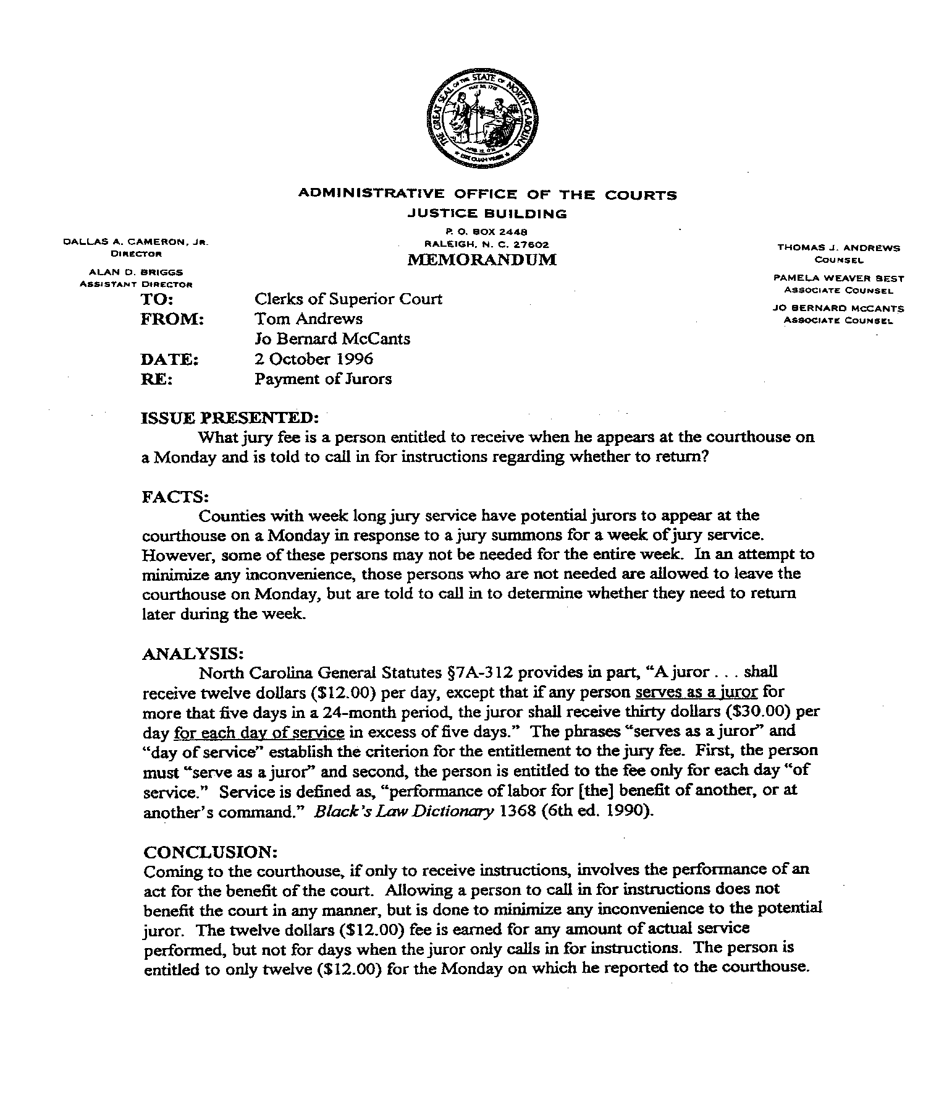

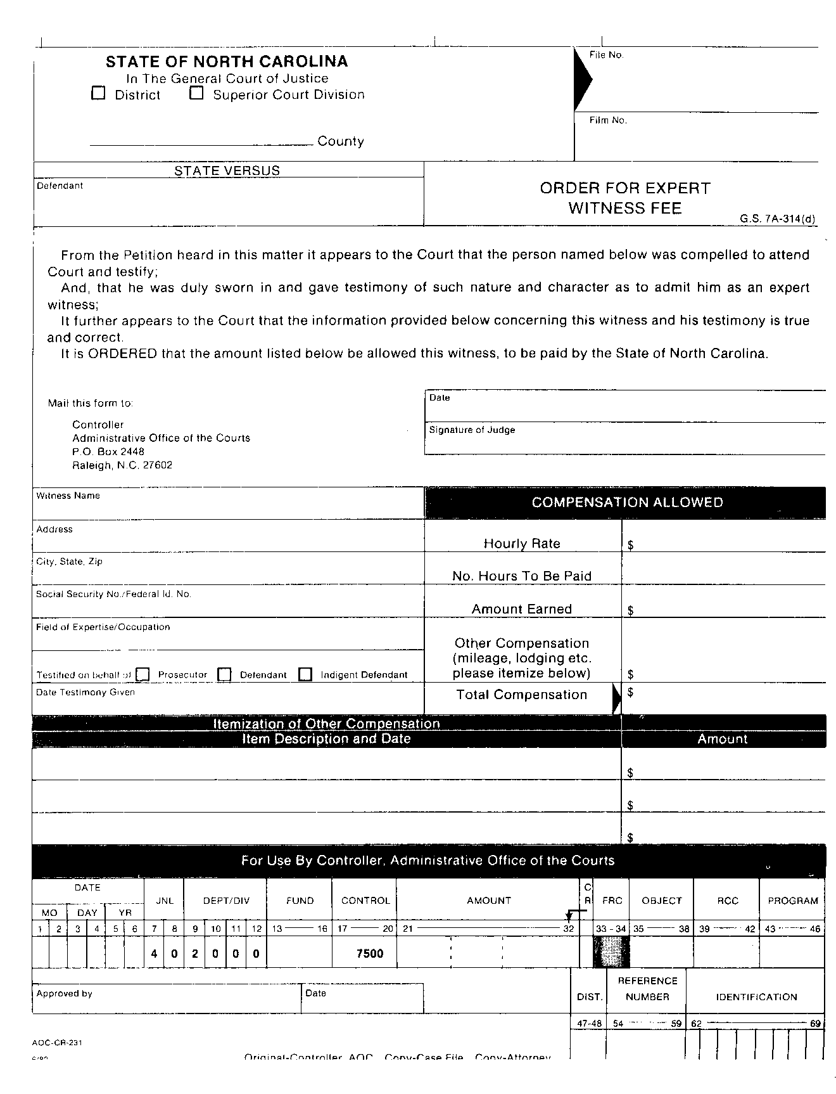

*SEE CHAPTER 18, PARTIAL PAYMENTS*

1. State Auditors may view the use of SCASH as an audit finding. Please contact your Financial Management Analyst (FMA) if you feel your office needs the use of this passkey.
2. An email version of the form can also be found at the Email Bulletin Board, AOC FORMS.
3. Obtaining demographic information about the juror is not advised. Information such as sex, race, date of birth, marital status, etc. should not be obtained.
4. The SSN is included in case the Juror would be required to receive a 1099-INT at the end of the calendar year.
5. See [Appendix F for a copy of the AOC memo from Tom Andrews and Jo Bernard McCants dated  
   October 2, 1996](#appendixF), for further clarification of “days served”.
6. See the FMS Manual, Chapter 3 - “PROCESSING FUNCTIONS”.
7. Contact the AOC Financial Services Division to obtain the current mileage rate.
8. If the Judge orders amounts to be paid that exceed the State employee’s per diem the AOC recommends that you comply with the Judge’s order.
9. Remember, if you voided a jury check because it was returned undeliverable or the owner refuses to cash it, you should transfer the funds to the escheat account (24500). This should be done at the same time you void the check in order to keep the account in balance. (See Chapter 21 (ESCHEATS), Section ESCHEATING FUND 10 OUTSTANDING CHECKS (including Jury checks). (NOTE for Merri, this one won’t work as I didn’t include 21 in the test)
10. If the witness is a minor, the payment should be made payable to the minor.
11. See the FMS Manual, Chapter 3 - “PROCESSING FUNCTIONS”.
12. Contact the AOC Financial Services Division to obtain the current mileage rate.
13. Contact the AOC Financial Services Division to obtain the current rates.
14. If you have an order signed by a Judge, you still need a completed Witness Attendance Certificate Form. If the Judge orders amounts to be paid that exceed the State employee’s per diem the AOC recommends that you comply with the Judge’s order.
15. See the FMS Manual, Chapter 3 - “PROCESSING FUNCTIONS”.
16. This does not include Expert Witness fees. See the Section EXPERT WITNESS FEES AND EXPENSES.
17. It is possible that the Judge’s order and the Witness Attendance Certificate Form have different amounts as witness fees and/or expenses. If you have this situation, the defendant should only be taxed the amount that is on the Witness Attendance Certificate Form.
18. The Partial Pay application distributes per the FMS priority.
19. This form is currently not obtainable via the nccourts.org website.
20. A 1099Misc would need to be issued if the expert witness was paid more than $600 in a calendar year for fees. (Do not include lodging and mileage reimbursement when determining whether or not a 1099Misc should be issued.)
21. The AOC combines all funds they paid to the expert witness for all 100 counties in the state.
22. See the FMS Manual, Chapter 3 - “PROCESSING FUNCTIONS”
23. It is possible that the Judge’s order and the Order for Expert Witness Fee Form have different amounts as expert witness fees and/or expenses. If you have this situation, the defendant should only be taxed the amount that is on the Order for Expert Witness Fee Form.
24. The Partial Pay application distributes per the FMS priority.
25. A 1099Misc would need to be issued if the interpreter was paid more than $600 in a calendar year for fees. (Do not include lodging and mileage reimbursement when determining whether or not a 1099Misc should be issued.)
26. The AOC combines all funds they paid to the interpreter for all 100 counties in the state.
27. See the FMS Manual, Chapter 3 - “PROCESSING FUNCTIONS”.
28. Only a language fee can be added to a bill of cost; deaf fees should not be included on a bill of cost. (G.S. 8b-8) (http://www.ncleg.net/EnactedLegislation/Statutes/HTML/BySection/Chapter_8B/GS_8B-8.html)
29. It is possible that the Judge’s order and the Motion, Appointment and Order Authorizing Payment of Interpreter Form have different amounts as interpreter fees and/or expenses. If you have this situation, the defendant should only be taxed the amount that is on the Motion, Appointment and Order Authorizing Payment of Interpreter Form.
30. The Partial Pay application distributes per the FMS priority.
31. Due to the AOC’s accounts payable system, there is a slight chance that the AOC reimbursement checks will also include payment for other reimbursable accounts (Petty Purchases, Due from AOC – Miscellaneous, etc.). If you cannot determine the accounts that total the check contact your Financial Management Analyst (FMA).